**Heuristic Evaluation Report**

Date: 11/14/2019

Prepared By (team member names): Colin Knebl

***Evaluation***

Name of website being evaluated: Mini Fans

Describe the scenario you used to focus your evaluation:

I am a new use of Mini Fans that wants to attend an event listed on the site. I am told I need to RSVP for the even on Mini Fans, but was not instructed on how to register.

**Problem #1**

The home page does not show any events. There are only articles that are visible. In order to view the events, I have to click on the ‘Meet-Ups’ button in the navigation.

Insert print screen, location of problem:

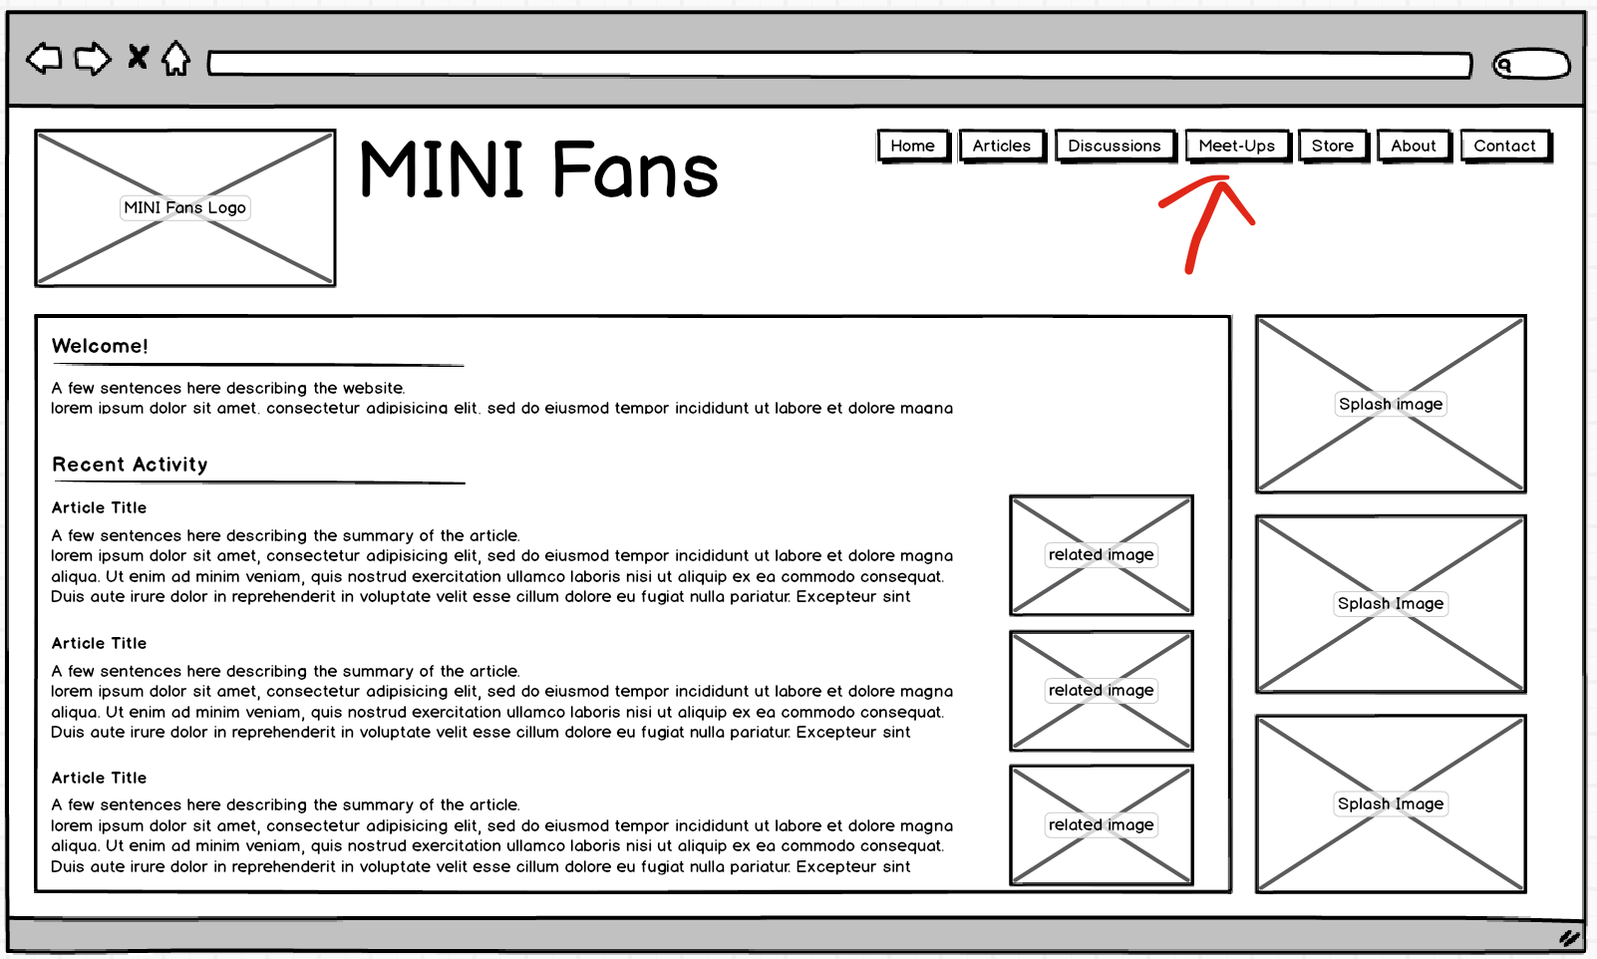

Name of heuristic: #6: Recognition rather than recall

Reason for reporting negative or positive: negative

Scope of problem: Looking for a way to RSVP

Severity of problem (high/medium/low): medium

Justification for severity rating: A user may bounce from the page if they cannot find the location to RSVP for an event

Suggestions to fix: Add a section to the home page that has a listing of upcoming events as well as a link to ‘view all event’

Possible trade-offs (why fix might not work): May create too much clutter on the home page.

**Problem #2**

The line length of the text spans a large portion of the viewport.

Insert print screen, location of problem:

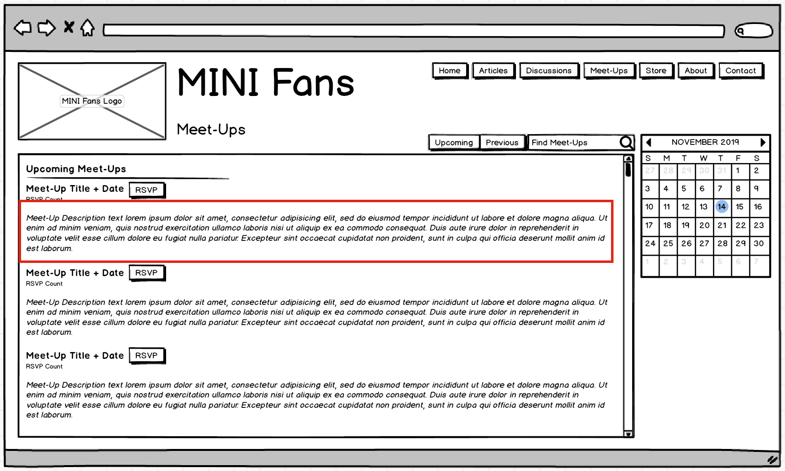

Name of heuristic: #8: Aesthetic and minimalist design

Reason for reporting negative or positive: negative

Scope of problem: Many of the pages on the site have long line lengths

Severity of problem (high/medium/low): low

Justification for severity rating: it does not impact the usability/functionality of the site

Suggestions to fix: make the main content area narrower, or add multiple columns of events

Possible trade-offs (why fix might not work): adding additional columns may be overwhelming for the user.